Temporary Accessibility Solutions for Election Day
Prepared by:
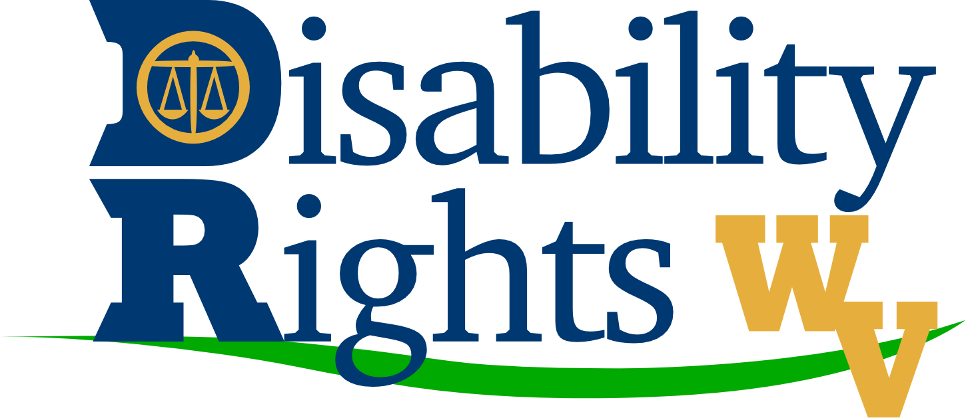
The Help America Vote Act (HAVA) is a federal law which ensures that each and every American citizen who is legally eligible to vote is able to fully exercise their right to vote; it makes the voting process and the voting place accessible to ALL eligible voters.
Protection and Advocacy for Voting Access (PAVA) was established in 2003 as part of HAVA. PAVA ensures that legally eligible individuals with disabilities have full participation in the electoral process through voter education regarding registering to vote, casting a vote and accessing the polling sites. West Virginia Advocates (WVA) is the grantee for PAVA.
The following are accommodations that can be made to temporarily resolve common accessibility issues on Election Day:
- Problem: Entrance door to the building is heavy and difficult to open.
- Solution: Keep the door propped open or station volunteers near the door to open it for voters.

- Problem: The accessible entrance is different from other entrance(s).
- Solution: Place signs at key points/areas to direct voters with disabilities to the voting area.

- Problem: The voting area is not on an accessible route and cannot be made accessible.
- Solution: Look for another area where accessible voting may be provided.
- Problem: Lack of Accessible Parking
- Solution: Traffic cones, or other temporary elements, may be used to mark the spaces and access aisles that are closest to the accessible entrance. Provide a sign designating each accessible parking space.

- Problem: The accessible route crosses a curb and no curb ramp is provided or one or two steps are part of the walkway leading to the accessible entrance
- Solution: Install a portable ramp with edge protection and handrails.

- Remember: The accessible voting area must be on an accessible route and have an accessible entrance with adequate circulation and maneuvering space for voters who use wheelchairs or scooters or who walk with mobility aids. Each polling site should have at least ONE accessible electronic voting machine.

The U.S. Election Assistance Commission (EAC) has created a video on Making Polling Places Accessible. It can be found online at http://www.eac.gov/making_polling_places_accessible/. The ADA Checklist for Polling Places can be found online at http://www.ada.gov/votingchecklist.htm. WVA’s Voting Rights video, People With Disabilities Vote!, can be found online at: http://www.youtube.com/user/wvadvocates.
Please contact West Virginia Advocates at 304-346-0847 or toll free at 1-800-950-5250 if you have any questions regarding the information provided, or need assistance.
WVA’s website may be an additional resource for you. It includes a wealth of useful information on various disability and non-disability topics. Go to www.wvadvocates.org and choose the “Resources” tab. From there, scroll down to the category that interests you. Please check back for frequently for updates and additions. WVA can also be found on Facebook. Go to http://www.facebook.com/wvadvocates then “like” us to receive updates.
Funding for this publication is provided by the U.S. Department of Health and Human Services, Administration for Community Living, Administration on Intellectual and Developmental Disabilities.

